# SOAR Village Database

## A few general comments:

* Please format all dates like this: YYYY/MM/DD. (Nice to have but not essential: drop-down calendar to choose dates)
* We’re all not IT specialists, but we suppose it shouldn't be too hard to change the writing in the menu once the database programme is written. As we’re working in a bilingual environment, it would be great if we could later add Chinese translation to the menu so that our local workers can use it, too. We have some advanced users on the team who think they could possibly learn how to do that from you… ;-)
* Same about drop-down menus: we would need an option to add more to them later (e.g. a new diagnosis for a child we didn’t think about earlier). We think we would like drop-downs instead of text fields for much of the data because it will be easier to generate useful queries, especially in our multilingual environment (i.e. because of inconsistency with spellings, e.g. paediatrician vs. pediatrician)
* Below, we are making some suggestions about how this database could be structured, queries could be done, things could be flagged etc. All from a laymen’s perspective - if you (the experts!) have any better ideas, please ignore ours! ;-)

## Reports

* We need a way to print reports for each child individually. Maybe an option to choose which tabs to print? Or even which subsection on a tab? (e.g. “Medical Information/Measurements”: maybe only want to print a list of the weight?). Probably no need to print the “Attachment” tab.
* Maybe an option for the “Child’s Data” page to print it with or without picture?
* Those printouts should somehow have the child’s name on them (maybe header or footer?), option to add today’s date, page number, etc. (the usual…).

## Macintosh HD:Users:Claudia:Desktop:Screen Shot 2017-04-13 at 21.45.21.pngQueries

* What is going to make this database really useful for us is the ability to run queries. There’s probably too many different ways we would like to search it and we won’t think of all of them right now, so maybe instead of creating a few refined queries, could you somehow give us the option to create our own? I’m thinking of something like this example from a very different (Access based) database (screen-shot on the right).
* We could have a list to tick what we would like to export (e.g., “Chinese Name”, “DOB”, “Medication”). If the database could then be exported to, say Excel, we could use the data to create whatever list/form/table we need it in.
* It would be great if there’s a way to mark certain notes in different tabs with content that needs to be taken care of (maybe flag them somehow? Check box next to it?) so we can run a query for them and get a “to-do-list”! This should be linked for the content of the note sections from the “Notes”, “Assessment” and “Partnership” tabs (made a remark on each of those tabs).

## Homepage

*First page of the database: A list of all the children’s names (generated from the data in the database) like example below. Click on the name opens the dossier. There should be a search option so we can write a name (either in Chinese, Pinyin or the English name) and then the corresponding dossier shows up.*

*Normally, only active dossiers should be visible. Need a way/filter/button to show inactive dossiers (see “Child’s Data” tab).*

*Maybe a button/an option somewhere to print out this list as a whole? (including option to export the list to excel)*

|  |  |  |  |  |  |  |
| --- | --- | --- | --- | --- | --- | --- |
| **Chinese Name** | **Pinyin Name** | **English Name** | **Sex** | **DOB** | **Current Carer** | **Carer Name Pinyin** |
| 李红军 | Li Hong Jun | Anna | F | 2008/03/04 |  |  |
|  |  |  |  |  |  |  |
| *from tab “Child’s Data”* | *from tab “Child’s Data”* | | | *from tab “Child’s Data”* | *from tab “Carer Information”* | |

## Tabs

Each dossier should have the following tabs:

* Child’s Data
* Medical Information
* Developmental Milestones
* Carer Information
* Assessment
* Notes
* Attachments
* Partnership
* Adoption/Fostering

The following pages explain what each tab should contain. Tab headings are marked in green.

## Child’s Data

Photo

Chinese Name: Pinyin Name: *picture linked from “Attachments” tab*

Text Box

Text Box

Text Box

English Name: Nickname:

Text Box

DOB: Age: <number calculated from DOB> years

Date

Drop-down

Sex :

Abandonment Date:

Date

Programme Entry Date:

Date

Date

Text Box

Programme Departure Date: Reason:

Child’s History:

Text Box (either the box gets bigger if needed or there’s a scroll option)

*If field “Programme Departure Date” is NOT empty, the dossier needs to become inactive, meaning we would still want to somehow access the child’s data (maybe through the first page – inactive dossiers could move to the bottom of the list?), but it should not show up in any queries other than one for “inactive dossiers”*

## Medical Information

*This tab should contain the sub-sections “Basic Medical Information, Medication, Measurements and Doctor Visits”*

Basic Medical Information

Drop-down

Drop-down

Drop-down

Diagnosis:

*Maybe we can have 3 drop-down boxes for diagnosis (all with the same menu) and a button to add further boxes if needed? (3 should be enough for most children, but not necessarily for everyone)*

**Dropdown menu list for “Diagnosis” (by far not complete - needs to be customizable!)**

* CP
* Autism
* Intellectual Disability
* ADHD
* Lennox-Gastaut
* Angelman Syndrome
* PKU
* Cleft Lip / Cleft Palate
* Hepatitis B

Text Box (either the box gets bigger if needed or there’s a scroll option)

Significant Medical History:

Medication

|  |  |  |  |  |  |  |
| --- | --- | --- | --- | --- | --- | --- |
| **Medication Name** | **Dosage** | | | **Start Date** | **End Date** | **Stopped** |
| <drop-down> | <number> | <number> | <number> | <date> | <date> | <tick box> |
|  |  |  |  |  |  |  |
| *Example:* |  |  |  |  |  |  |
| Carbamazepine 卡马西平100mg | 1 | 0 | 1 | 2015/08/12 |  |  |
| Valproate 丙戊酸钠200mg | 0.5 | 0 | 0 | YYYY/MM/DD |  |  |
| Phenobarbital 苯巴比妥30mg | 1 | 0 | 0 | 2000/01/01 | 2017/04/13 | Macintosh HD:Users:Claudia:Desktop:Screen Shot 2017-04-13 at 18.15.30.png |

* *Once the box “stopped” is ticked, the record should turn greyish and move below the white, active ones. Currently taken meds should be at the top, and only those should be considered when running queries for medication.*
* *There may be a problem here if dosage changes and people just overwrite the numbers as we will then loose the history. Suggestion: If dosage changes, stop the current medication with today’s end date and start a new line with the new dosage and today as start date.*
* *Query for “Medication Name” and “Dosage” should display the results in the above case as follows:*

Carbamazepine 卡马西平100mg 1-0-1

Valproate 200mg 丙戊酸钠0.5-0-0

**Dropdown menu list for “Medication Name” (needs to be customizable to add new meds):**

* Carbamazepine卡马西平 100mg
* Lamotrigine 拉莫三嗪 50mg
* Phenobarbital苯巴比妥 30mg
* Topiramate妥泰 25mg
* Valproate丙戊酸钠 200mg
* Haloperidol氟哌啶醇 2mg
* Quetiapine富马酸喹硫平 100mg
* Risperidone 利培酮 1mg

Measurements

* We need a way to document the progression for the following 4 parameters:
* weight (units: kg)
* height (units: cm)
* MUAC (units: cm)
* Head Circumference (units: cm)
* That means that under the sub-section “Measurements”, there will be 4 tables. Latest entry at the top.
* For queries, there should be a way to just include the latest of each these 4 parameters (e.g. searching for “Chinese Name”, “current weight”, “date of latest weight” would create a list with each child’s latest weight and the date when it was taken)
* Each table needs a field for date, measurement result and comments. Example for Weight:

|  |  |  |
| --- | --- | --- |
| **Date** | **Weight** | **Comments** |
| <date> | <number> kg | <text> |
|  |  |  |
| *2017/04/13* | *23.5 kg* | *wiggling* |
| *2017/03/11* | *23.0 kg* | *was wearing clothes* |

Doctor Visits

|  |  |  |  |
| --- | --- | --- | --- |
| **Date** | **Seen by** | **Facility / Name of Physician** | **Notes** |
| <date> | <drop-down> | <text> | <text> |

**Dropdown menu list for “Seen by” (needs to be customizable to add others):**

* Paediatrician
* Neurologist
* Dentist
* OT
* PT
* Ophthalmologist
* EG doctor

## Developmental Milestones

*Three sections (Communication Milestones, Physical Milestones, Life-Skills) as below:*

|  |  |  |
| --- | --- | --- |
| **Communication Milestones** | **Reached** | **Date** |
| Vocalizes | <tick box> | <date> |
| Responds to name | <tick box> | <date> |
| Says 2-3 words | <tick box> | <date> |
| Says several words | <tick box> | <date> |
| Says sentences containing subject & verb | <tick box> | <date> |
| Converses in sentences | <tick box> | <date> |
| Can count | <tick box> | <date> |

|  |  |  |
| --- | --- | --- |
| **Physical Milestones** | **Reached** | **Date** |
| Sits alone | <tick box> | <date> |
| Crawls | <tick box> | <date> |
| Stands alone | <tick box> | <date> |
| Walks with assistance | <tick box> | <date> |
| Walks alone | <tick box> | <date> |

|  |  |  |
| --- | --- | --- |
| **Life-Skills** | **Reached** | **Date** |
| Uses simple gestures (i.e. bye-bye, shakes head) | <tick box> | <date> |
| Drinks from a cup | <tick box> | <date> |
| Eats with a spoon | <tick box> | <date> |
| Toilet trained | <tick box> | <date> |
| Scribbles | <tick box> | <date> |
| Copies shapes | <tick box> | <date> |

## Carer Information

**Current Carer:**

|  |  |  |  |  |
| --- | --- | --- | --- | --- |
| **Name of Carer** | **Pinyin Name** | **From** | **To** | **Notes** |
| <text> | <text> | <date> | <date> | <text, scroll option if needed?> |

**Carer History:**

|  |  |  |  |  |
| --- | --- | --- | --- | --- |
| **Name of Carer** | **Pinyin Name** | **From** | **To** | **Notes** |
| <text> | <text> | <date> | <date> | <text, scroll option if needed?> |

*We somehow need to see at one glance who the current carer is (want her visibly separated from the list of carer history). So maybe have two sections like suggested above with “Current Carer” and “Carer History” and the current carer moves down to the “carer history” list once the “to” date is filled in? Or maybe you have a better idea how that could work… ;-)*

*There should be a button/option to add lines when needed. Sort list with latest date at the top and oldest at the bottom.*

*Current carer would not be included in this list, but her name (both Chinese and Pinyin) is linked to the list on the Homepage.*

## Assessment

Dates of Initial Assessment:

**OT** Date: <date> Assessed by: <text> Notes: <text>

**PT** Date: <date> Assessed by: <text> Notes: <text>

**SLP** Date: <date> Assessed by: <text> Notes: <text>

Assessment History:

|  |  |  |  |  |
| --- | --- | --- | --- | --- |
| **Date** | **Seen by** | **Speciality** | **Notes** | **Flag** |
| <date> | <text> | <drop-down> | <text, scroll option if needed?> | Macintosh HD:Users:Claudia:Desktop:Screen Shot 2017-04-13 at 18.15.30.png |

**Dropdown menu list for “Speciality” (customizable):**

* OT
* PT
* SLP
* PSY

*Button to add lines when needed, newest date at the top*

*Option needed to flag “Notes” to easily find them when generating a search (combined with the flags from the “Notes” and “Partnership” tabs of the database. Maybe a tick-box on the right to the entry?*

## Notes

Camp History

|  |  |  |
| --- | --- | --- |
| **Date** | **Camp** | **Notes** |
| <date> | <drop-down> | <text> |

**Drop-down menu list (customizable):**

* Bring me Hope
* Bridge of Hope
* Joy in the Journey

Notes

|  |  |  |
| --- | --- | --- |
| **Date** | **Notes** | **Flag** |
| <date> | <text, scroll option if needed?> | Macintosh HD:Users:Claudia:Desktop:Screen Shot 2017-04-13 at 18.15.30.png |
|  |  |  |
| *Example:* |  |  |
| 2017/03/22 | Had to vomit after lunch. Carer says he was jumping too wild on the trampoline right after lunch. Seems to be doing fine later. |  |
| 2017/04/05 | Need to buy XY for him. | Macintosh HD:Users:Claudia:Desktop:Screen Shot 2017-04-13 at 18.15.30.png |

*Button to add lines needed, newest date at the top.*

*Option needed to somehow flag the notes for easier search.*

*Option needed to delete lines (the note to buy something is flagged so it will show up in a query for all flagged items and can be used for a to-do-list. But once the item is bought, there’s no need to keep this entry. The other notes we will want to keep as they are a record of what is happening with the child.*

*Actually, the option to delete entries might be useful for other tables, too, as mistake do happen… (I have worked with databases where that was not easily possible, so just want to mention it here…)*

## Attachments

On this tab, we would like to have space to attach the following for each child:

* **Photos**: the latest one can be used for the photo on the “Child’s Data” tab, but we would like to keep older ones for our record. In order to prevent the database from getting too big, maybe have them automatically resized to screen resolution (we’ll keep the original elsewhere for printing out).
* **Care Plans**: Word document or PDF. There will be a new one every 6 months, but we would like to keep the older ones and have the new at the top
* **GAS Goals**: Same as Care Plans
* **Medical Records**: space to upload scanned medical records
* **Miscellaneous**

Maybe those attachments can be somehow organised like this example from an SAP database (except that they are NOT chronological in this screen-shot…)? Any other ideas are welcome!

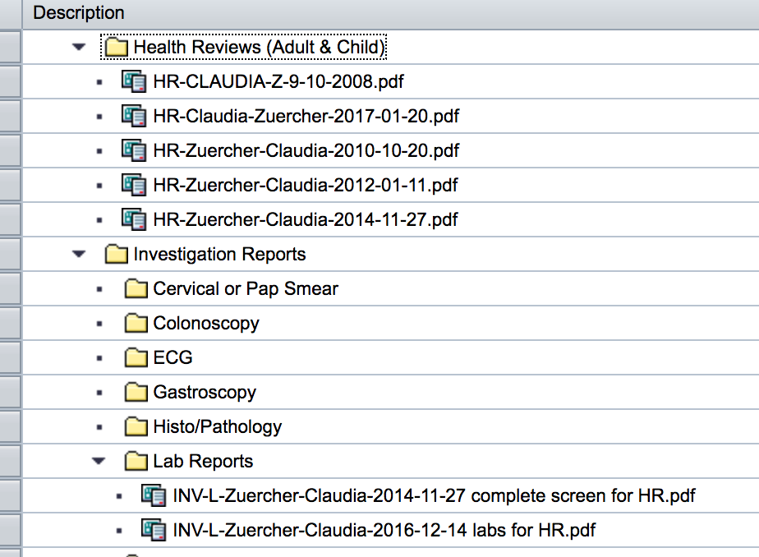

## Partnership

*We need a record for the people praying for this child. They may do that for a while (let’s say a year) and then stop and we may have a new partner. So there needs to be a way to keep track of this and have a history of all the partners.*

**Data needed for each partner:**

* Name <text>
* E-mail
* Address
* Phone
* Start Date <date>
* End Date <date>
* Status <switch> (active/inactive)
* Notes <text> (with flag option like the notes on the “Notes” and “Assessment” tabs)

## Adoption/Fostering

Fostering

Text

Date

Fostering Date: Notes:

Adoption Process

Ages Out: <date> *[This date is automatically calculated from the DOB. A child ages out on their 14th birthday. If it is possible to do this, once this date is reached, could the “Orphanage Status” below automatically change to “aged out”? If not, we can just do that manually. Also, once the child has aged out, the section “Agency Status” and “Adopting Family” could just disappear]*

Text

**Orphanage Status:** <drop-down> Notes:

* aged out
* no file
* police notice
* file pulled
* SWI file complete

**Process Started:** <date>

**Agency Status:**

Text

Agency Name <text field> Notes:

Family Pursuing <tick box>

Shared List <tick box>

Process Started <date>

**Adopting Family:**

Text

Family Name <text> Notes:

Family E-Mail <text>

Phone Number <text>

Address <text>

Adoption Date <date>